**Lab 06**

**21k-3881**

**Task Example:**

CREATE TABLE Book (

BookId NUMBER NOT NULL,

Title VARCHAR2 (50),

Author_First_name VARCHAR2 (25) NOT NULL,

Author_Last_Name VARCHAR2 (25) NOT NULL ,

Rating INTEGER

) ;

ALTER TABLE Book ADD CONSTRAINT Book_PK PRIMARY KEY ( BookId ) ;

CREATE TABLE Patrons (

PatronId NUMBER NOT NULL ,

Last_name VARCHAR2 (25) NOT NULL,

First_name VARCHAR2 (25) NOT NULL,

Street_address VARCHAR2 30,

City VARCHAR2 20,

State VARCHAR2 (2) ,

Zip NUMBER ,

Location VARCHAR2 20

) ;

ALTER TABLE Patrons ADD CONSTRAINT Patrons_PK PRIMARY KEY ( PatronId ) ;

CREATE TABLE Transactions (

TransactionID NUMBER NOT NULL ,

BookID NUMBER NOT NULL ,

patronID NUMBER NOT NULL ,

transactionDate DATE NOT NULL ,

Transaction_Type CHAR (50 CHAR) NOT NULL ,

Patrons_PatronId NUMBER NOT NULL ,

Book_BookId NUMBER NOT NULL

) ;

ALTER TABLE Transactions ADD CONSTRAINT Transactions_PK PRIMARY KEY (

TransactionID ) ;

ALTER TABLE Transactions ADD CONSTRAINT Transactions_Book_FK FOREIGN KEY (

Book_BookId ) REFERENCES Book ( BookId ) ;

ALTER TABLE Transactions ADD CONSTRAINT Transactions_Patrons_FK FOREIGN KEY (

Patrons_PatronId ) REFERENCES Patrons ( PatronId ) ;

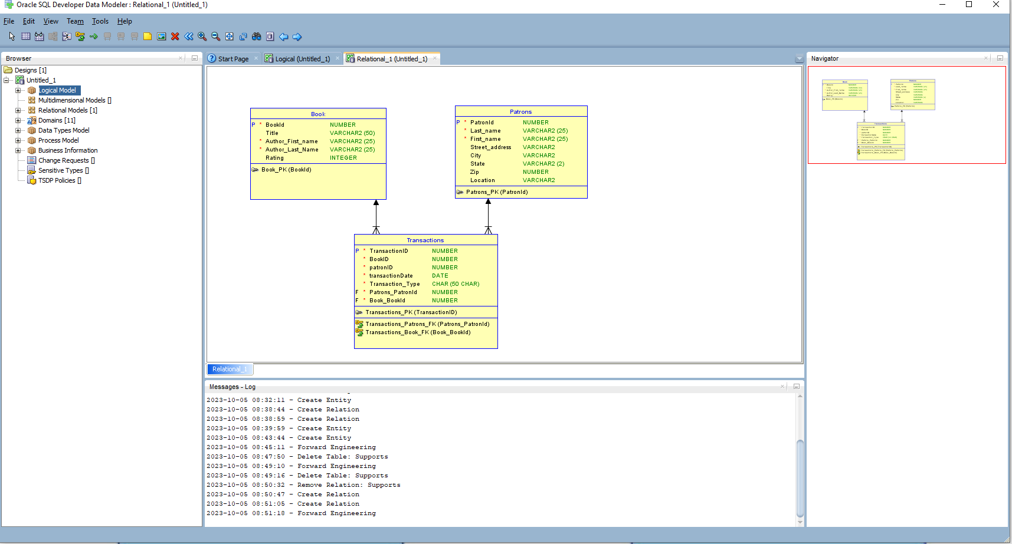

**Task 01:**

CREATE TABLE Customers (

Customer_ID NUMBER NOT NULL ,

Name VARCHAR2 (25) NOT NULL ,

Product_name VARCHAR2 (50) NOT NULL ,

Quantity INTEGER NOT NULL ,

Address VARCHAR2 (50) NOT NULL ,

Employees_EmployeeID NUMBER NOT NULL

) ;

ALTER TABLE Customers ADD CONSTRAINT Customers_PK PRIMARY KEY ( Customer_ID ) ;

CREATE TABLE Employees (

EmployeeID NUMBER NOT NULL ,

First_Name VARCHAR2 (25) NOT NULL ,

Last_Name VARCHAR2 (25) NOT NULL ,

Address VARCHAR2 (50) NOT NULL

) ;

ALTER TABLE Employees ADD CONSTRAINT Employees_PK PRIMARY KEY ( EmployeeID ) ;

CREATE TABLE Orders (

Order_Number NUMBER NOT NULL ,

Quantity NUMBER ,

Shipped_date DATE ,

Recieved_Date DATE ,

Customers_Customer_ID NUMBER NOT NULL

) ;

ALTER TABLE Orders ADD CONSTRAINT Orders_PK PRIMARY KEY ( Order_Number )

CREATE TABLE Products (

Product_ID NUMBER NOT NULL ,

Name VARCHAR2 (25) NOT NULL ,

Price NUMBER NOT NULL ,

Stock NUMBER NOT NULL ,

Employees_EmployeeID NUMBER NOT NULL

) ;

ALTER TABLE Products ADD CONSTRAINT Products_PK PRIMARY KEY ( Product_ID ) ;

ALTER TABLE Customers ADD CONSTRAINT Customers_Employees_FK FOREIGN KEY (

Employees_EmployeeID ) REFERENCES Employees ( EmployeeID ) ;

ALTER TABLE Orders ADD CONSTRAINT Orders_Customers_FK FOREIGN KEY (

Customers_Customer_ID ) REFERENCES Customers ( Customer_ID ) ;

ALTER TABLE Products ADD CONSTRAINT Products_Employees_FK FOREIGN KEY (

Employees_EmployeeID ) REFERENCES Employees ( EmployeeID ) ;

